## Mini Project Report On

**LIBRARY MANAGEMENT SYSTEM**

## *Submitted By:*

***Name:- Rahul Arora***

***College Id:- 1911985024***

**CERTIFICATE**

*Certified that this is a bonafide record of the project work titled “* **LIBRARY MANAGEMENT SYSTEM ”**

*Done by Rahul Arora*

# ACKNOWLEDGEMENT

We take this occasion to thank God, almighty for blessing us with his grace and taking our endeavor to a successful culmination. We extend our sincere and heartfelt thanks to our esteemed guide, , for providing us with the right guidance and advice at the crucial junctures and for showing me the right way. We also take this opportunity to express a deep sense of gratitude to our class coordinators, andfor their cordial support, valuable suggestions and guidance. We extend our sincere thanks to our respected **Head of the division** , for allowing us to use the facilities available. We would like to thank the other faculty members also, at this occasion. Last but not the least, we would like to thank our friends and family for the support and encouragement they have given us during the course of our work.

## TABLE OF CONTENTS

ABSTRACT 5

1. INTRODUCTION 6
   1. PROJECT AIMS AND OBJECTIVES 6
   2. BACKGROUND OF PROJECT 7
   3. OPERATION ENVIRONMENT 8
2. SYSTEM ANALYSIS 9
   1. SOFTWARE REQUIREMENT SPECIFICATION 9
   2. EXISTINGVS PROPOSED 15
   3. SOFTWARE TOOLUSED 16
3. SYSTEM DESIGN 20
   1. TABLE DESIGN 20
   2. DATA FLOW DIAGRAM’S 24
4. SYSTEM IMPLEMENTATION 30
   1. MODULE DESCRIPTION 30
   2. SCREENSHOTS 80
5. SYSTEM TESTING 85
   1. UNITTESTING 85
   2. INTEGRATION TESTING 87
6. CONCLUSION & FUTURE SCOPE 88

#### ABSTRACT

##### Library management system is a project which aims in developing a computerized system to maintain all the daily work of library .This project has many features which are generally not available in normal library management systems like facility of user login and a facility of teachers login .It also has a facility of admin login through which the admin can monitor the whole system .It also has facility of an online notice board where teachers can student can put up information about workshops or seminars being held in our colleges or nearby colleges and librarian after proper verification from the concerned institution organizing the seminar can add it to the notice board . It has also a facility where student after logging in their accounts can see list of books issued and its issue date and return date and also the students can request the librarian to add new books by filling the book request form. The librarian after logging into his account ie admin account can generate various reports such as student report , issue report, teacher report and book report

Overall this project of ours is being developed to help the students as well as staff of library to maintain the library in the best way possible and also reduce the human efforts.

**CHAPTER:-1 INTRODUCTION**

This chapter gives an overview about the aim, objectives, background and operation environment of the system.

#### PROJECT AIMS AND OBJECTIVES

The project aims and objectives that will be achieved after completion of this project are discussed in this subchapter. The aims and objectives are as follows:

* + - Online book issue
    - Request column for librarian for providing new books
    - A separate column for digital library
    - Student login page where student can find books issued by him/her and date of return.
    - A search column to search availability of books
    - A teacher login page where teacher can add any events being organized in the college and important suggestions regarding books.
    - Online notice board about the workshop.

#### BACKGROUND OF PROJECT

Library Management System is an application which refers to library systems which are generally small or medium in size. It is used by librarian to manage the library using a computerized system where he/she can record various transactions like issue of books, return of books, addition of new books, addition of new students etc.

Books and student maintenance modules are also included in this system which would keep track of the students using the library and also a detailed description about the books a library contains. With this computerized system there will be no loss of book record or member record which generally happens when a non-computerized system isused.

In addition, report module is also included in Library Management System. If user’s position is admin, the user is able to generate different kinds of reports like lists of students registered, list of books, issue and return reports.

All these modules are able to help librarian to manage the library with more convenience admin a more efficient way as compared to library systems which are non-computerized.

#### OPERATION ENVIRONMENT

|  |  |
| --- | --- |
| PROCESSOR | INTEL CORE PROCESSOR OR BETTER PERFORMANCE |
| OPERATING SYSTEM | WINDOWS VISTA ,WINDOWS7, UBUNTU |
| MEMORY | 1GB RAM OR MORE |
| HARD DISK SPACE | MINIMUM 3 GB FOR DATABASE USAGE FOR FUTURE |
| DATABASE | MONGODB |

**CHAPTER:- 2**

**SYSTEM ANALYSIS**

In this chapter, we will discuss and analyze about the developing process of Library Management System including software requirement specification (SRS) and comparison between existing and proposed system. The functional and non functional requirements are included in SRS part to provide complete description and overview of system requirement before the developing process is carried out. Besides that, existing vs proposed provides a view of how the proposed system will be more efficient than the existing one.

#### SOFTWARE REQUIREMENT SPECIFICATION

* + 1. **GENERAL DESCRIPTION**

PRODUCT DESCRIPTION:

Library Management System is a computerized system which helps user (librarian) to manage the library daily activity in electronic format. It reduces the risk of paper work such as file lost, file damaged and time consuming.

It can help user to manage the transaction or record more effectively and time- saving.

PROBLEM STATEMENT:

The problem occurred before having computerized system includes:

* + - File lost

When computerized system is not implemented file is always lost because of human environment. Sometimes due to some human error there may be a loss of records.

* + - File damaged when a computerized system is not there file is always lost due to some accident like spilling of water by some member on file accidently. Besides some natural disaster like floods or fires may also damage the files.
    - Difficult to search record

When there is no computerized system there is always a difficulty in searching of records if the records are large in number.

* + - Space consuming

After the number of records become large the space for physical storage of file and records also increases if no computerized system is implemented.

* + - Cost consuming

As there is no computerized system to add each record paper will be needed which will increase the cost for the management of library.

#### SYSTEM OBJECTIVES

* + - Improvement in control and performance

The system is developed to cope up with the current issues and problems of library

.The system can add user, validate user and is also bug free.

* + - Save cost

After computerized system is implemented less human force will be required to maintain the library thus reducing the overall cost.

* + - Save time

Librarian is able to search record by using few clicks of mouse and few search keywords thus saving his valuable time.

* + - Option of online Notice board

Librarian will be able to provide a detailed description of workshops going in the college as well as in nearby colleges

* + - Lecture Notes

Teachers have a facility to upload lectures notes in a pdf file having size not more than 10mb

#### SYSTEM REQUIREMENTS

* + - 1. NON FUNCTIONAL REQUIREMENTS
         * Product Requirements EFFICIENCY REQUIREMENT

When a library management system will be implemented librarian and user will easily access library as searching and book transaction will be very faster.

RELIABILITY REQUIREMENT

The system should accurately performs member registration, member validation , report generation, book transaction and search

USABILITY REQUIREMENT

The system is designed for a user friendly environment so that student and staff of library can perform the various tasks easily and in an effective way.

ORGANIZATIONAL REQUIREMENT IMPLEMENTATION REQUIREMNTS

In implementing whole system it uses html in front end with php as server side scripting language which will be used for database connectivity and the backend ie the database part is developed using mongodb or mysql.

DELIVERY REQUIREMENTS

The whole system is expected to be delivered in six months of time with a weekly evaluation by the project guide.

* + - 1. FUNCTIONAL REQUIREMENTS

1. NORMAL USER
2. USER LOGIN

Description of feature

This feature used by the user to login into system. They are required to enter user id and password before they are allowed to enter the system .The user id and password will be verified and if invalid id is there user is allowed to not enter the system.

Functional requirements

-user id is provided when they register

-The system must only allow user with valid id and password to enter the system

-The system performs authorization process which decides what user level can access to.

-The user must be able to logout after they finished using system.

* + REGISTER NEWUSER

Description of feature

This feature can be performed by all users to register new user to create account.

Functional requirements

-System must be able to verify information

-System must be able to delete information if information is wrong

* + REGISTER NEW BOOK Description of feature

This feature allows to add new books to the library Functional requirements

-System must be able to verify information

-System must be able to enter number of copies into table.

- System must be able to not allow two books having same book id.

1.5 SEARCH BOOK

DESCRIPTION OF FEATURE

This feature is found in book maintenance part. we can search book based on book id , book name , publication or by author name.

Functional requirements

* System must be able to search the database based on select search type
* System must be able to filter book based on key word entered.
* System must be able to show the filtered book in table view.
  1. ISSUE BOOKS AND RETURN BOOKS

DESCRIPTION OF FEATURE

This feature allows to issue and return books and also view reports of book issued.

Functional requirements

-System must be able to enter issue information in database.

-System must be able to update number of books.

- System must be able to search if book is available or not be for reissuing books

-System should be able to enter issue and return date information

* 1. EVENTADDITION

DESCRIPTION OF FEATURE

This feature allows teacher and student to add information about various workshops being conducted in college and colleges nearby.

Functional requirements

-System should be able to add detailed information about events.

-System should be able to display information on notice board available in the homepage of site

#### SOFTWARE AND HARDWARE REQUIREMENTS

This section describes the software and hardware requirements of the system

* + - 1. SOFTWARE REQUIREMENTS
         * Operating system- Windows 7 is used as the operating system as it is stable and supports more features and is more user friendly
         * Database MONGODB is used as database as it easy to maintain and retrieve records by simple queries which are in English language which are easy to understand and easy to write.
         * Development tools and Programming language- HTML is used to write the whole code and develop web pages with css, javascript for styling work and php for sever side scripting.
      2. HARDWARE REQUIREMENTS
* Intel core i5 2nd generation is used as a processor because it is fast than other processors an provide reliable and stable and we can run our pc for longtime. By using this processor we can keep on developing our project without any worries.
* Ram 1gb is used as it will provide fast reading and writing capabilities and will in turn support in processing

#### EXISTING VS PROPOSED SYSTEM

* + 1. Existing system does not have any facility of teachers login or student login where as proposed system will have a facility of student login as well as teacher’s login
    2. Existing system does not have a facility of online reservation of books whereas proposed system has a facility of online reservation of books
    3. Existing system does not have any facility of online notice board where description of workshops happening in our college as well as nearby colleges is being provided.
    4. Existing system does not has any option of lectures notes uploaded by teachers whereas proposed system will have this facility
    5. Existing system does not have any facility to generate student reports as well book issue reports whereas proposed system provides librarian with a tool to generate reports
    6. Existing system does not has any facility for book request and suggestions where as in proposed system after logging in to their accounts student can request books as well as provide suggestions to improve library.

#### SOFTWARE TOOLS USED

The whole Project is divided in two parts the frontend and the backend.

* + 1. Frontend

The frontend is designed using of Html ,React ,CSS, JavaScript

* + 1. BACKEND

The back end is designed using mongodb which is used to design the databases

## CHAPTER:-3 SYSTEM DESIGN

#### TABLE DESIGN

VARIOUS TABELS TO MAINTAIN INFORMATION

 BOOK TABLE FOR KEEPING TRACK OF BOOKS

|  |  |  |  |  |
| --- | --- | --- | --- | --- |
| **Field** | **Data type** | **Default** | **Key** | **Extra** |
| Code | INT(11) | Not Null | Primary | Auto increment |
| Book name | VARCHAR(255) | Null |  |  |
| Author | VARCHAR(255) | Null |  |  |
| Publication | VARCHAR(255) | Null |  |  |
| Subject | VARCHAR(255) | Null |  |  |
| No of copies | INT(10) | Null |  |  |

* STUDENT TABLE FOR STUDENT INFORMATION

|  |  |  |  |  |
| --- | --- | --- | --- | --- |
| **Field** | **Data type** | **Default** | **Key** | **Extra** |
| Lib id | INT(11) | NOT NULL | Primary key | Auto increment |
| Reg no | INT(10) | NULL |  |  |
| branch | VARCHAR(255) | NULL |  |  |
| section | VARCHAR(255) | NULL |  |  |
| semester | VARCHAR(255) | NULL |  |  |
| section | VARCHAR(2) | NULL |  |  |
| Year of adm | INT(5) | NULL |  |  |

### TEACHER TABLE TO KEEP TEACHER INFORMATION

|  |  |  |  |  |
| --- | --- | --- | --- | --- |
| **Field** | **Data Type** | **Default** | **Key** | **Extra** |
| Tid | INT(11) | NOT NULL | Primary key | Auto increment |
| Name | VARCHAR(255) | NULL |  |  |
| Designation | VARCHAR(255) | NULL |  |  |
| Branch | VARCHAR(255) | NULL |  |  |
| Contact no | INT(13) | NULL |  |  |
| Lectures | LONG BLOB | NULL |  |  |

* Issue table to keep track of books issued

|  |  |  |  |  |
| --- | --- | --- | --- | --- |
| **Field** | **Data Type** | **Default** | **Key** | **Extra** |
| Book id | INT(11) | NOT NULL | Foreign key | References book |
| Student id | INT(11) | NOT NULL | Foreign key | References Student |
| Issue date | DATE | NULL |  |  |
| Return date | DATE | NULL |  |  |

* STUDENT LOGIN TABLE

|  |  |  |  |  |
| --- | --- | --- | --- | --- |
| **Field** | **Data type** | **Default** | **Key** | **Extra** |
| Login id | INT(11) | NOT NULL | Foreign key | References Student |
| Username | VARCHAR(255) | NULL |  |  |
| Password | VARCHAR(255) | NULL |  |  |
| Num books | INT(1) | NULL |  |  |

* EVENT TABLE FOR EVENT INFORMATION

|  |  |  |  |  |
| --- | --- | --- | --- | --- |
| **Field** | **Data type** | **Default** | **Key** | **Extra** |
| Name | Varchar(255) | NULL |  |  |
| Date | Date(yyyy/mm/dd) | NULL |  |  |
| Time | VARCHAR(255) | NULL |  |  |
| Mname | VARCHAR(255) | NULL |  |  |
| Contactno. | Int(30) | NULL |  |  |
| Email | VARCHAR(255) | NULL |  |  |
| Venue | varchar(255) | NULL |  |  |

* TEACHER LOGIN TABLE

|  |  |  |  |  |
| --- | --- | --- | --- | --- |
| **Field** | **Data Type** | **Default** | **Key** | **Extra** |
| Loginid | INT(11) | NOT NULL | Foreign key | References teacher |
| Username | VARCHAR(255) | NULL |  |  |
| Password | VARCHAR(255) | NULL |  |  |

#### DATA FLOW DIAGRAMS

DATA FLOW DIAGRAM FOR TEACHER LOGIN

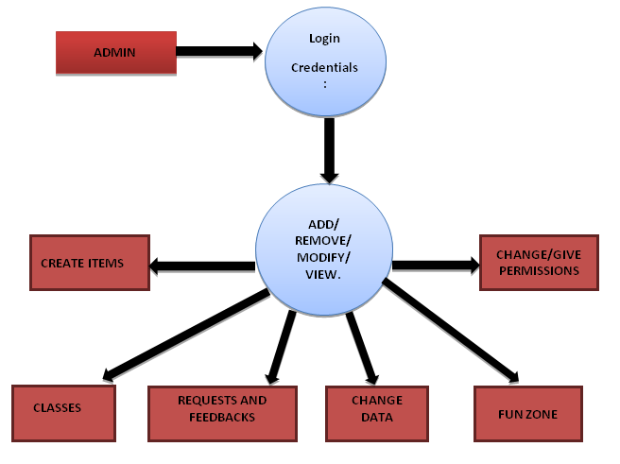TEACHER

DATABASE

After entering to the home page of the website , teacher can choose the TEACHER LOGIN option where they are asked to enter username & password , and if he/she is a valid user then a teacher login page will be displaye

DATA FLOW DIAGRAM FOR STUDENT LOGIN

STUDENT

DATABASE

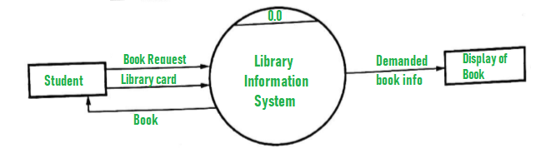

After entering to the home page of the website , student can choose the STUDENT LOGIN option where they are asked to enter username & password , and if he/she is a valid user then a student login page will be displayed.

DATA FLOW DIAGRAM FOR BOOK ISSUE

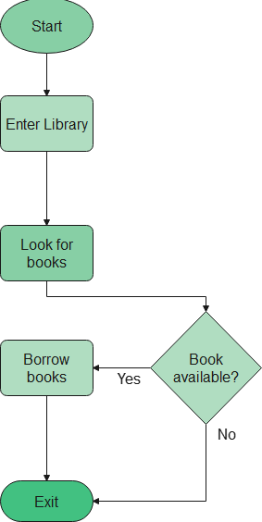

Itisa2ndlevelDataFlowDiagramwhereafterenteringSTUDENTLOGINpagehe/shecanselect a book issue option where after entering the book detail, he/she can select the book issue option and if the maximum no of books issued limit is not crossed then a request will be sent to the librarian who will approve the book issue.

DATA FLOW DIAGRAM FOR ACCOUNT CREATION

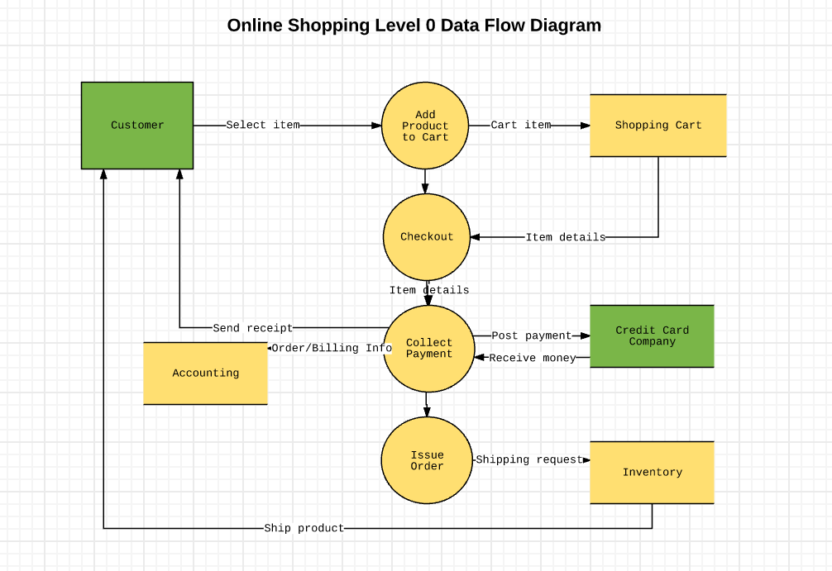

After the home page login there will be an option of CREATE AN ACCOUNT where after entering student detail ,if all the fields are filled then a request will be sent to the librarian who will approve him as a registered member of the library.

## CHAPTER:-4

**SYSTEMIMPLEMENTATION**

###### 4.1.1 Screenshot for homepage

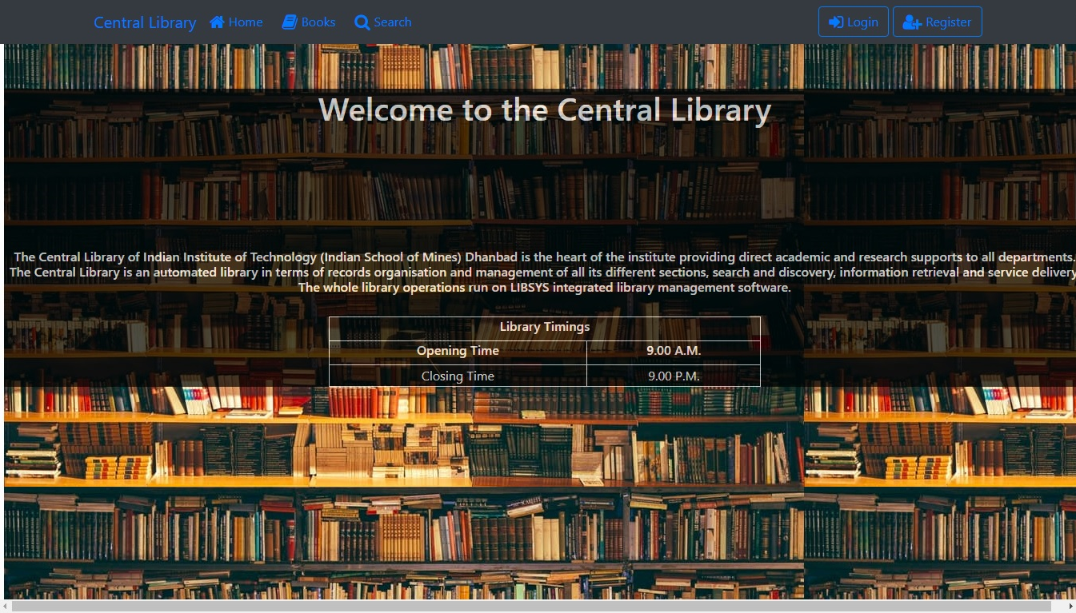

###### Screenshot for Admin login

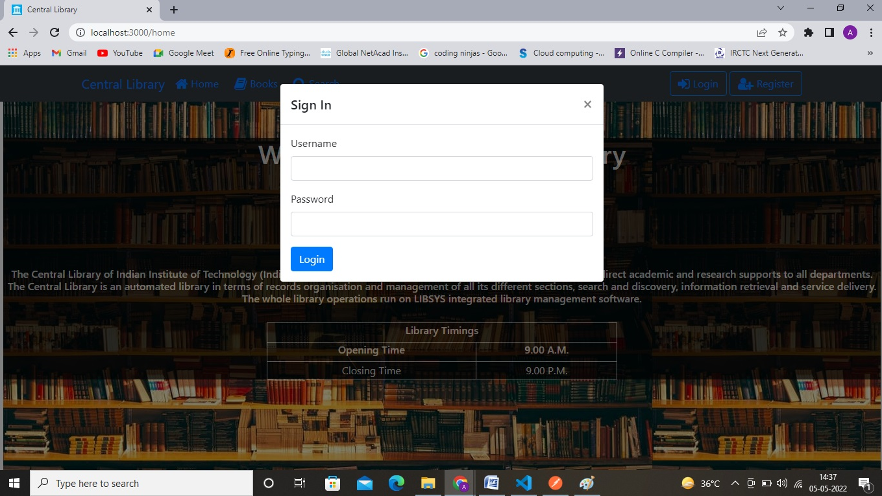

###### 4.1.2 Screenshot for Student login



###### 4.1.3 Screenshot for teacher’s login



###### 4.1.2 Screenshot for Book search

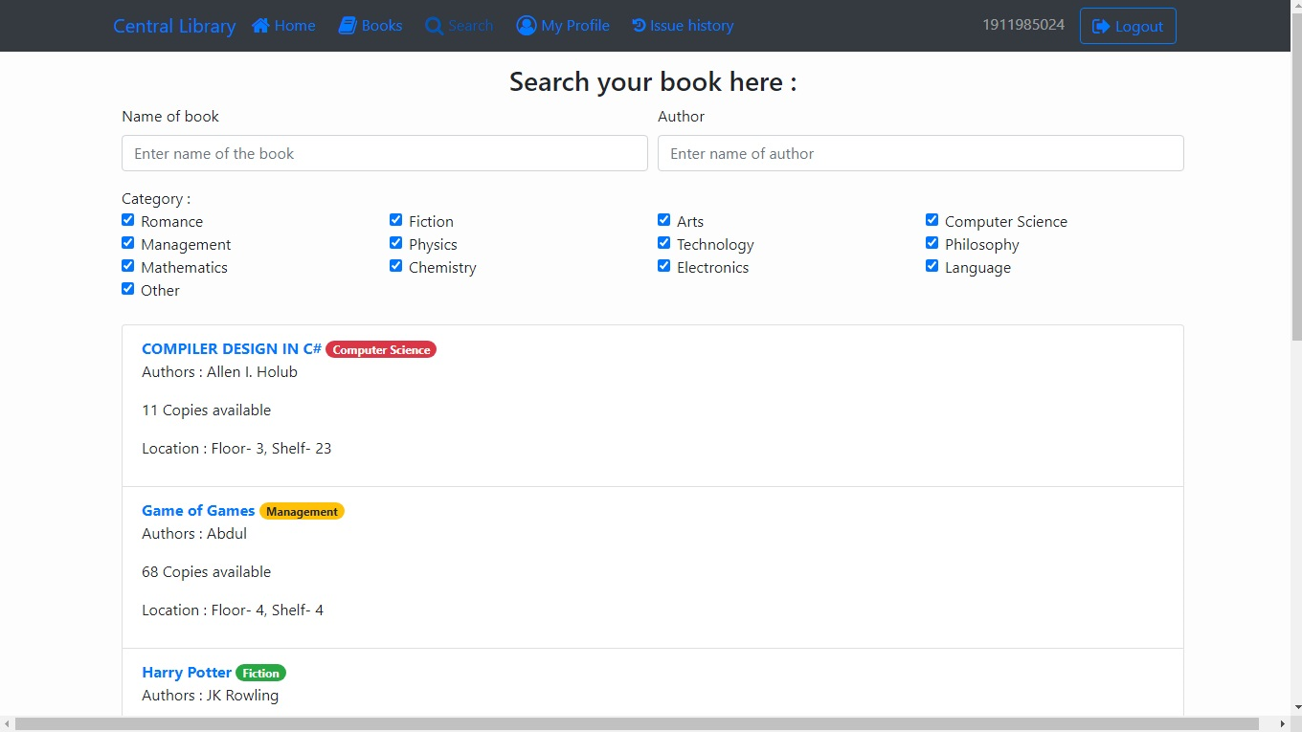

# CHAPTER:-5 SYSTEM TESTING

The aim of the system testing process was to determine all defects in our project .The program was subjected to a set of test inputs and various observations were made and based on these observations it will be decided whether the program behaves as expected or not.

Our Project went through two levels of testing 1.Unit testing

1. Integration testing

## UNIT TESTING

Unit testing is undertaken when a module has been created and successfully reviewed .In order to test a single module we need to provide a complete environment ie besides the module we would require

* + The procedures belonging to other modules that the module under test calls
  + Non local data structures that module accesses
  + A procedure to call the functions of the module under test with appropriate parameters

Unit testing was done on each and every module that is described under module description of chapter 4

1. Test For the admin module
   * Testing admin login form-This form is used for log in of administrator of the system. In this we enter the username and password if both are correct administration page will open otherwise if any of data is wrong it will get redirected back to the login page and again ask for username and password
   * Student account addition- In this section the admin can verify student details from student academinc info and then only add student details to main library database it contains add and delete buttons if user click add button data will be added to student database and if he clicks delete button the student data will be deleted
   * Book Addition- Admin can enter details of book and can add the details to the main book table also he can view the books requests.
2. Test for Student login module
   * Test for Student login Form-This form is used for log in of Student .In this we enter the library id, username and password if all these are correct student login page will open otherwise if any of data is wrong it will get redirected back to the login page and again ask for library id, username and password.
   * Test for account creation- This form is used for new account creation when student does not fill the form completely it asks again to fill the whole form when he fill the form fully it gets redirected to page which show waiting for conformation message as his data will be only added by administrator after verification.
3. Test for teacher login module-
   * Test for teacher login form- This form is used for login of teacher .In this we enter the username and password if all these are correct teacher login page will open otherwise if any of data is wrong it will get redirected back to the login page and again ask for username and password.

## INTEGRATION TESTING

In this type of testing we test various integration of the project module by providing the input

.The primary objective is to test the module interfaces in order to ensure that no errors are occurring when one module invokes the other module.

# CHAPTER:-6

# CONCLUSION & FUTURE SCOPE

This website provides a computerized version of library management system which will benefit the students as well as the staff of the library.

It makes entire process online where student can search book, staff can generate reports and do book transactions. It also has a facility for student login where student can login and can see status of books issued as well request for book or give some suggestions. It has a facility of teacher’s login where teachers can add lectures notes and also give necessary suggestion to library and also add info about workshops or events happening in our college or nearby college in the online notice board.

There is a future scope of this facility that many more features such as online lectures video tutorials can be added by teachers as well as online assignments submission facility , a feature Of group chat where students can discuss various issues of engineering can be added to this project thus making it more interactive more user friendly and project which fulfills each users need in the best way possibl